Angela’s Ashes by Frank McCourt
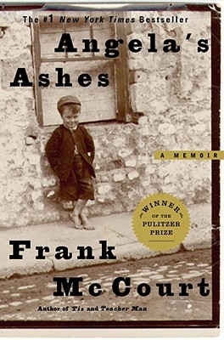

The Power of Story: Inspiring Passion, Purpose,
and Leadership Potential

Disposition: Leadership qualities

Themes:
- The power of the individual
- Camouflage hides identity and enables imitating of others in order to survive and even flourish.

Words to think about:
- "Do not let what you cannot do interfere with what you can do." - John Wooden
- “Those who do not have power over the story that dominates their lives, the power to retell it, rethink it, deconstruct it, joke about it, and change it as times change, truly are powerless, because they cannot think new thoughts.” - Salman Rushdie
- Leadership and learning are indispensable to each other. - John F. Kennedy
- Example is leadership. - Albert Schweitzer

Essential Questions:
- How do I know if I am developing the academic skills that I need in my future life?
- How can I effectively articulate my opinions and perspectives?
- What can I do to avoid repeating mistakes made in history?
- What leadership skills have I developed?
- What leadership qualities will I need to take me from high school?
- What qualities define a good world citizen?
- How can I create the world I want to live in?
- How can I use my talents to create new opportunities for myself and for others?
Heads-up on the Assessment!
This is what you need to focus on while reading, writing, and learning throughout this unit.

I WILL LEARN: | Date Learned:
Theme: The power of the individual
Theme: Camouflage hides identity and enables imitating of others in order to survive and even flourish
Reading Strategy: summary
Reading Strategy: inference
Reading Strategy: How do I relate?
Genre: memoir
Genre: expository article
Element of Writing: persuasion/argumentation
Element of Writing: extended metaphor
Element of Writing: lesson
Element of Writing: strong nouns and verbs
Element of Writing: external conflict
Element of Writing: imagery
Element of Writing: symbolism

